In the present world, RPA and AI are becoming more and more significant. They can assist businesses in automating routine processes to boost productivity and cut costs. Data input, customer support, and accounting are a few examples of high-volume, low-complexity operations that can be automated with RPA. Contrarily, more difficult jobs like natural language processing, image identification, and predictive analytics can be performed using artificial intelligence (AI). AI may be used to create intelligent robots and systems that can work independently and learn from their experiences. RPA and AI are transforming the way work is done and helping organizations stay competitive in a rapidly changing digital landscape.  
  
**So what are Ai and RPA?**

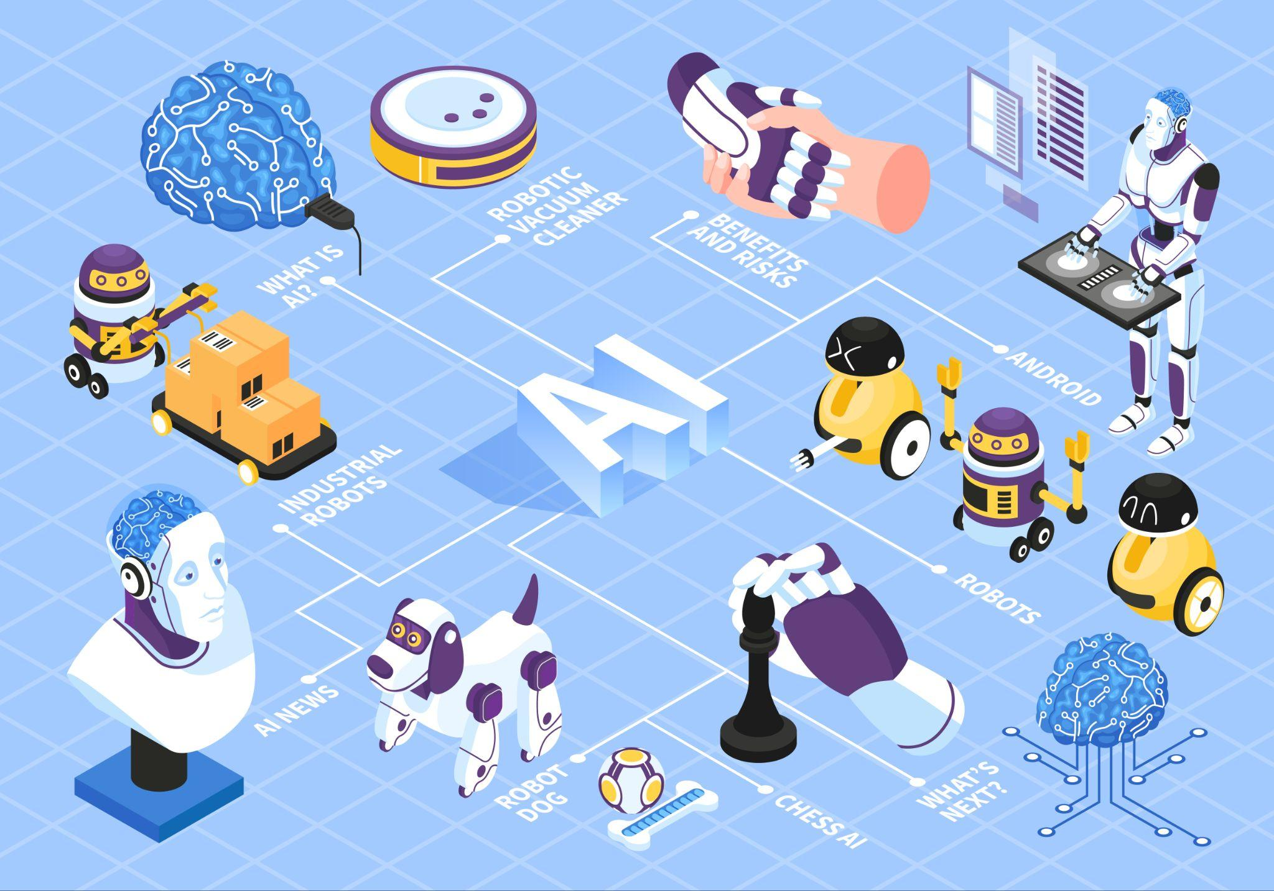  
Artificial intelligence (AI) involves the development of systems that are capable of performing tasks that ordinarily require human intelligence, such as learning, problem-solving, and decision-making.

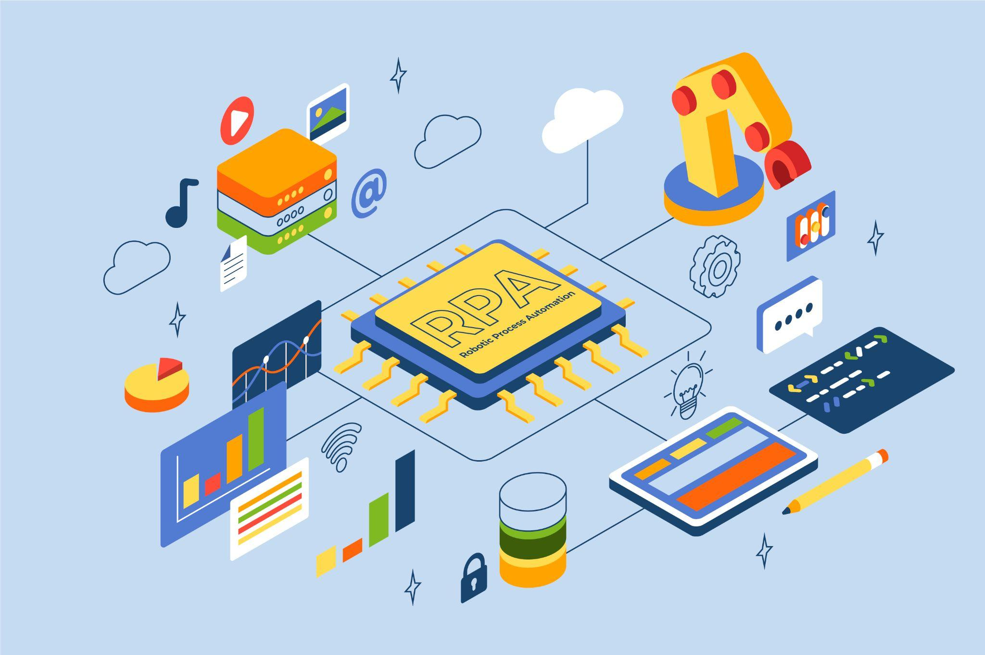

Robotic Process Automation (RPA) is a software technology that automates repetitive and rule-based tasks by imitating human actions.

RPA focuses on automating structured, repetitive operations, whereas AI aims to provide machines with the ability to carry out complex processes that were previously only achievable for humans.  
  
**Why should you do RPA and Ai?**

RPA and AI are becoming more and more significant in the current world as a result of their ability to assist businesses to automate repetitive operations, boosting productivity, and cutting expenses. Data input, customer support, and accounting are a few examples of high-volume, low-complexity operations that can be automated with RPA. In addition, more difficult jobs like natural language processing, image identification, and predictive analytics can be accomplished using artificial intelligence (AI). AI can also be used to develop intelligent systems and machines that can operate autonomously and learn from experience. In many industries, RPA and AI are transforming the way work is done and helping organizations stay competitive in a rapidly changing digital landscape.  
  
**What do we do?**

Misc Archive can help you automate and improve your recurring operations using the RPA platform. This decreases the need for manual intervention while increasing accuracy and efficiency. RPA conducts lengthy, difficult activities by recreating and improving how a human would typically carry them out. RPA is comparatively simple to adopt into your operations when correctly implemented and compatible with your current infrastructure and systems. You can quickly alter and optimise the solution once the Systems are operational.

Our main platform for developing these apps is Microsoft Power Automate and related automation modules.

* Extremely quick implementation.
* Without interfering with the underlying architecture.
* Used to eliminate manual entry methods from all business activities.
* Used to extract text and image information from documents that are structured, semi-structured, and unstructured.

**Why choose us?**

Misc Archive focuses on delivering high-quality software solutions that meet the needs and requirements of our business audience. We make sure that our products are reliable, and user-friendly, and provide value to our customers. We offer additional services such as technical support, maintenance, and upgrades to improve the overall customer experience.  
  
For more details, Please feel free to contact us.